Japa Pohn’s Pizza Delivery Application
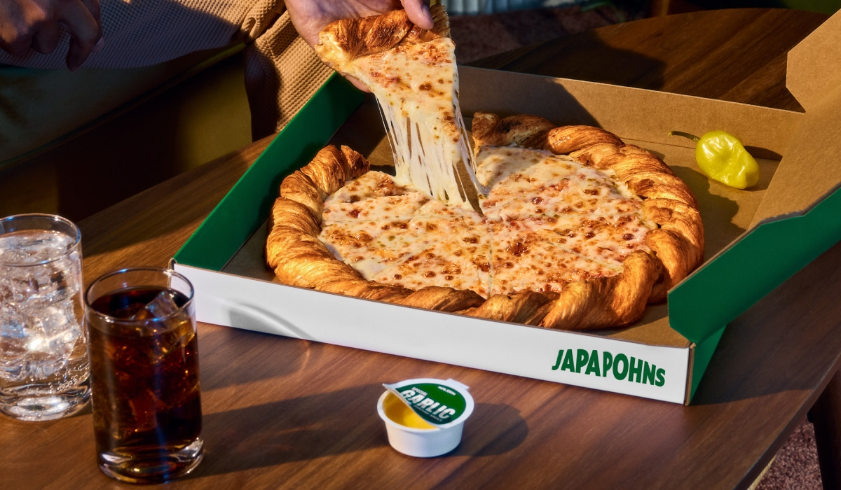
By: Donovan Cunningham, Luke Craven, Rashad, Hudson, and Ved Rakholia
Project Plan 1
Scope 1
Schedule 2-3
Team Organization 4
Team Roles: 4
Resumes: 5-7
Technical Description 8-9
Data Management Plan 9
Test Plan 9-10

Scope:
1. Order/Record Keeping System
- Order Placement System
- Account Creation/Editing System
- SQL Interface
- SQL Database
2. Website Development
- Develop Front End
- Setup Pizza Menu
- Hook Front end to Record Keeping Service
3. Implement Payment Processor and Recipe Printing
- Implement Lemon Squeezie as the payment processor
- Configure Java backed to send receipts to a standard printer

Schedule :
Task ID | WBS | Planned Start | Planned Finished | Workload Planned | Workload | Complete %
1 | Order/Record Keeping System | 24th Sep | NLT Oct 1st | 9hr |  | 0
1.1 | Order Placement System | 24th Sep | NLT Oct 1st | 3hr |  | 0
1.2 | Account Creation/Editing System | 24th Sep | NLT Oct 1st | 1.5hr |  | 0
1.3 | SQL Interface | Oct 1st | NLT Oct 8th | 3hr |  | 0
1.4 | SQL Database | Oct 1st | NLT Oct 8th | 1.5hr |  | 0
2 | Website Development | Oct 8th | NLT Oct 15th | 3hr |  | 0
2.1 | Develop Front End | Oct 8th | NLT Oct 15th | 1.5hr |  | 0
2.2 | Setup Pizza Menu | Oct 8th | NLT Oct 15th | 0.5hr |  | 0
2.3 | Hook Front end to Record Keeping Service | Oct 8th | NLT Oct 15th | 1hr |  | 0
3 | Implement Payment Processor and Recipe Printing | Oct 15th | NLT Oct 22nd | 6hr |  | 0
3.1 | Implement Lemon Squeezie as the payment processor | Oct 15th | NLT Oct 22nd | 4hr |  | 0
3.2 | Configure Java backed to send receipts to a standard printer | Oct 15th | NLT Oct 22nd | 2hr |  | 0
4 | Test Phase | Oct 22nd | NLT Oct 31st | 16hr |  | 0

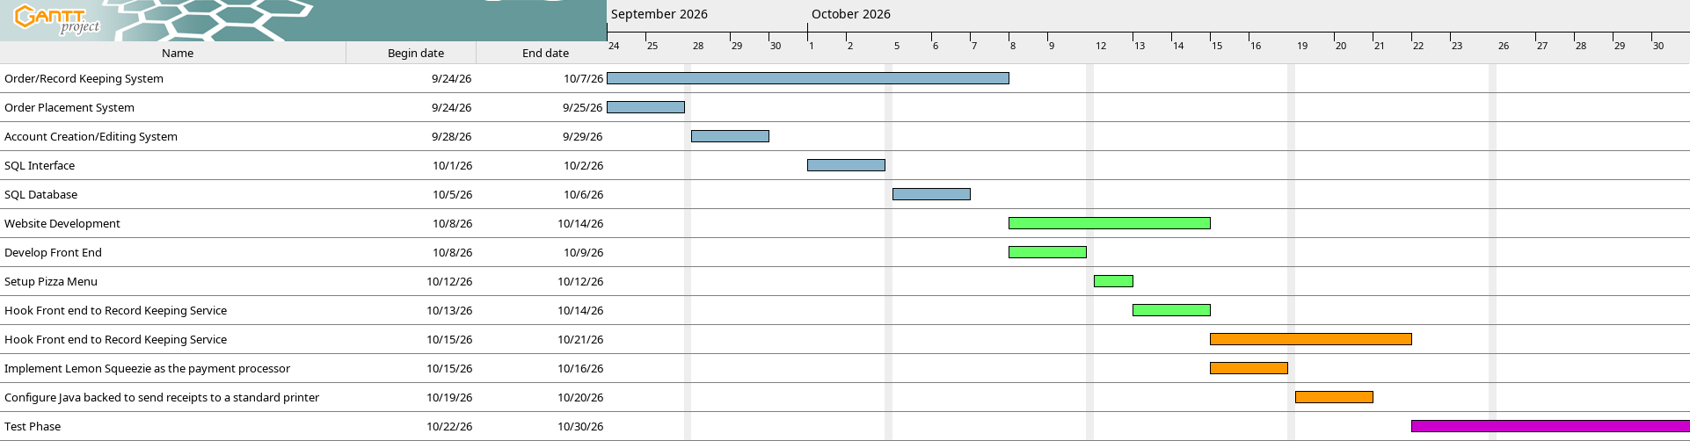
Gantt Chart:

Team Organization:

Donovan – SQL system and SQL back end hookup
Rashad - Java Order/Record Keeping System development
Ved - Front End Development
Luke Craven - Implement Payment Processor and Recipe Printing

Resumes:
Donovan Cunningham
__________________________________________________________________________
<Omitted Private Information>
Summary_____________________________________________________________
I am an experienced Computer Programmer looking to continue my career in Computer Science. I am technologically oriented. I work well under pressure, and will make just decisions while under pressure. I’ve also worked hands on with Linux and Windows systems and currently daily drive Kbuntu.
Highlights____________________________________________________________
· I worked with a team to develop and program an addon for the videogame Arma 3
· Currently Enrolled as a CS Student at Kennesaw State University
· I know Lua, Python, Java, C++ and C#
Work Experience___________________________
Computer Science Teacher
September 2017 to 2018
Rolling Robots - Glendale, CA
· Worked with Children teaching computer science and robotics construction
UAS Operator
October 2019 to October 2025
The United States Army - Fort Jackson, SC
· Learned the value of teamwork, self motivation, and hard work
The United States Army - Fort Huachuca, AZ
· Learned operations of Army UAS systems
The United States Army - Fort Stewart, GA
· Continued training on UAS systems. Developed and trained soldiers on FPV aircraft
Education____________________________________________________________
· Graduated at John Burroughs High School (May, 2017)
· Completed 1 Semester at Glendale Community College (December, 2018)
· Completed AIT at Fort Huachuca, AZ for UAS Operations
· Enrolled in Kennesaw State University for Computer Science
References_________________________________________________________
Available upon request

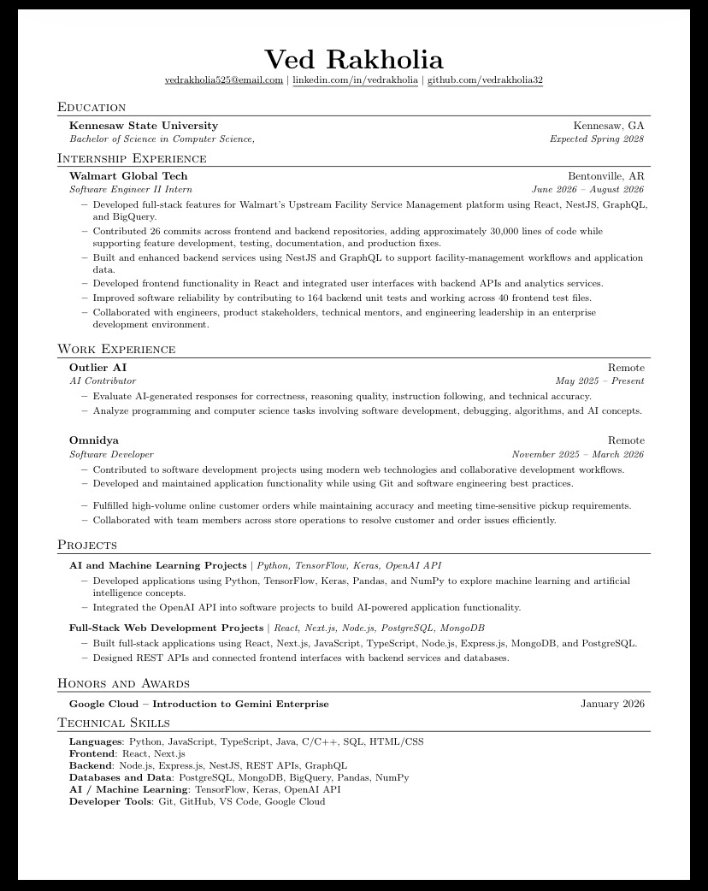
LUKE CRAVEN
Entry-Level IT Support | Help Desk | Computer Science Student
<Omitted Personal Information>
PROFESSIONAL SUMMARY
Computer Science student with 8 years of hands-on technical manufacturing experience, including equipment troubleshooting, repair, quality inspection, and five years of shift-lead responsibility. Familiar with Windows, Linux, Python, Java, C++, SQL, and modern development tools. Seeking an entry-level IT Support or Help Desk role where strong diagnostic, problem-solving, and technical learning skills can support users and systems.

TECHNICAL SKILLS
Operating Systems: | Windows, Linux
Programming: | Python, Java, C++, SQL, G-Code
Tools & Software: | VS Code, IntelliJ IDEA, Microsoft OneDrive, Autodesk Fusion 360
Technical Concepts: | Object-Oriented Programming, CAD/CAM, technical troubleshooting, analytical problem-solving

EDUCATION
- Bachelor's in Computer Science | Kennesaw State University | Expected May 2028
- Associate's in Precision Machining | Chattahoochee Technical College | March 2024
- CNC Technology Diploma | Chattahoochee Technical College | July 2023

PROFESSIONAL EXPERIENCE
PM Mold Technician | Piolax | Jan 2021 - Apr 2026
• Diagnosed tooling and equipment issues, disassembled molds, and completed cleaning and repairs to restore production equipment to operating condition.
• Performed precision manual-mill work and configured wire-machine setups, requiring careful measurement, process control, and attention to technical specifications.
• Served as a shift lead in a high-schedule tool room for five years, prioritizing work and helping maintain productivity under tight deadlines.
Machine Operator | Piolax | Apr 2018 - Dec 2020
• Inspected finished products for adherence to customer specifications and identified quality issues before release.
• Operated production equipment used to manufacture plastic automotive components while following defined procedures and quality standards.

IT-RELEVANT STRENGTHS
Troubleshooting & diagnostics • Technical documentation & specifications • Quality-focused work • Fast-paced task prioritization • Continuous technical learning
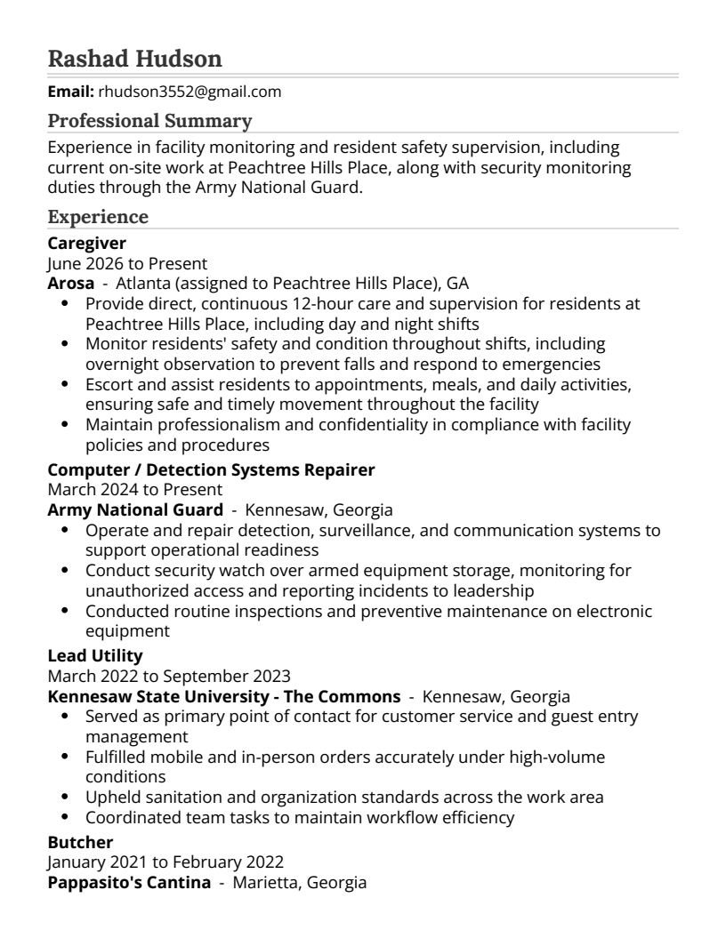
Technical Description:
The Pizza Ordering and Delivery System will be designed for a small pickup-and-delivery pizza shop. The system will allow employees to create and retrieve customer records, enter orders, calculate bills, process payments, maintain the restaurant menu, and print receipts. Since the shop does not provide dine-in service, the system will focus only on pickup and delivery orders. The user interface will be designed so that an employee can quickly move through the ordering process while speaking with a customer in person or over the phone. The main screens will include an opening screen, customer lookup screen, menu selection screen, payment screen, and receipt screen.
Opening Screen:
The opening screen will be the first screen displayed when the system starts. It will contain the name of the Pizza Shop and a button to begin using the system. The screen will be simple so that an employee can quickly continue to the customer lookup and order-entry process. The opening screen may also contain basic options such as Help and Exit. The purpose of this screen is to provide a clear starting point and make the application easy to understand.
Customer Lookup Screen:
The customer lookup screen will be used at the beginning of each customer transaction. Customer records will be identified by a separate key, differing from project requirements to improve database security. The employee will enter the customer's phone number into the system. If the customer already exists, the system will display the customer's name, phone number, address, subdivision, nearest major intersection, and other delivery information. The employee can confirm that the information is still correct before beginning the order. If the customer is new, the employee will create a customer record. The system will collect the customer's name, phone number, address, delivery information, and charge account type, such as Visa or MasterCard. The phone number will be used as tool for retrieving the customer record during future transactions. The employee will also indicate whether the order is for pickup or delivery. If the order is for delivery, the stored address and delivery information will be used.
Menu Selection Screen:
The menu selection screen will allow the employee to enter the customer's order through a graphical user interface. The menu will contain the pizza sizes, crust types, toppings, beverages, and other items offered by the Pizza Shop. For example, if a customer orders a medium thin-crust pizza with pepperoni and extra cheese, the employee will select the medium size, thin crust, pepperoni, and extra cheese from the available menu options. The system will display the selected items in an order summary. The employee will be able to change quantities, remove items, or add additional items before the order is completed. As menu items are selected, the system will automatically calculate the price of each item and the total amount due. The order summary will show the selected items, quantities, prices, and final amount
Data management plan:
SQL Database stores customer info via custom search index. Payment Info, and Address will be encrypted via password hash. Password stored as hash, using Public-key cryptography. User can change username, email, address and account deletion.
SQL Database stores order information in terms of quantity and type of pizzas being ordered, the delivery address or if the order is pickup, the name for the order, and when the order will be picked up (ASAP, 15 minuets – 2 hours). Managers will have access to all the records displayed on screen when logged in. This information will also be printed out when the order is placed, to both alert the kitchen staff that there is an order, and so that all kitchen employees know when and how to prepare the order.
Test plan:
The application phases have small blocks of time near the end to ensure that systems are communicating properly before moving onto the next phase of development. The full project will be assembled before major testing can being. Major testing will include several aspects such as duration testing, intensity, placing multiple orders at the same time, adjusting and deleting customer data, and ensuring printer functionality is present. The system will exist as an addressable website via a remote server, and all testing will be done connecting to this remove server via 4 parties.
To ensure application timelines are met, testing of individual milestones will cease the moment that the milestone deadline is reached. The project must continue to flow despite these deadlines, and a large chuck of final testing time is preserved to ensure that the application will have enough time to be worked on in the end. The project roles are also layed out and developed in a way where a single individual can work on one aspect individually if they extend their deadline period. As of now, all hours and time calculations are tentative, and there is no full understanding of how long the process will take, hence the large chunk of time in the end to rectify the program.
The end result of testing is a fully functional program that can handle multiple orders and several customer creation/deletion operations at the same time. There should also be functionality to highlight issues when they arise and an auto start script if the application is to crash at any point. Verbose logging of crashes should be written to a file for further debugging in the future to improve later iterations.
Users will be trained to navigate application screens and complete common customer tasks and transactions, including the login screen, customer lookup, and the order entry screen. Training will cover customer lookup by key, creating customer records, entering orders, selecting menu items, processing payments, and printing receipts. Users will know how to review customer and delivery information. Training will include a walkthrough of each screen followed by hands-on practice with sample orders. Training is considered complete when the user processes a full pickup or delivery order accurately and with little assistance.
Management will have access to previous orders and have the ability to issue refunds or prevent an order from going through if something is wrong or they are overstressed. Manager access will work the same as employee access, but will require a password to access the refunding option.

